OOP Homework Five

Teacher: Ching-Shun Lin

Content
Problem 1 . . . . . . . . . . . 2~8
（一） Complex class . . . . . . . . . . . . . . . . . . . . . . . . . . . . . . .2
（二） Complex class function . . . . . . . . . . . . . . . . . . . .. . . .2
（三） Total program and notes . . . . . . . . . . . . . . . . . . .. . . .4
（四） Running result . . . . . . . . . . . . . . . . . . . . . . . . . . . . . .7

Problem 2 . . . . . . . . . . . 9~19
（一） Date class . . . . . . . . . . . . . . . . . . . . . . . . . . . . . .. . . .9
（二） Date class function . . . . . . . . . . . . . . . . . . . . . . . .. . .9
（三） Total program and notes . . . . . . . . . . . . . . . . . .. . . .12
（四） Running result . . . . . . . . . . . . . . . . . . . . . . . . . . . . .17

Problem One
一、Complex class：

This complex class member include real part and imaginary part.
And class function include set, get, print, and some complex calculate operation.
Include addition, subtraction, multiplication, division.

class complex
{
private:
double realpart,imaginarypart;
public:
complex();
void set_complex(double,double);
void get_complex(double&,double&);
void print_complex(void);
complex operator+( complex&);
complex operator-( complex&);
complex operator*( complex&);
complex operator/( complex&);};
};

二、Complex class function：

（一）Initial class function：
complex::complex()
{
realpart=imaginarypart=0;
}

（二）Set complex function：
void complex::set_complex(double r,double i)
{
realpart=r;
imaginarypart=i;
}

（三）Get complex function：
void complex::get_complex(double& r,double& i)
{
r=realpart;
i=imaginarypart;
}

（四）Print complex function：
void complex::print_complex(void)
{
cout<<realpart;
if(imaginarypart<0)
{
cout<<imaginarypart<<'i'<<endl;
}
else
{
cout<<'+'<<imaginarypart<<'i'<<endl;
}
}

（五）Addition function：
complex complex::operator+( complex& c)
{
complex result;
result.realpart= realpart+ c.realpart;
result.imaginarypart= imaginarypart+ c.imaginarypart;
return result;
}

（六）Subtraction function：
complex complex::operator-( complex& c)
{
complex result;
result.realpart= realpart- c.realpart;
result.imaginarypart= imaginarypart- c.imaginarypart;
return result;
}

（七）Multiplication function：
complex complex::operator*( complex& c)
{
complex result;
result.realpart= (realpart*c.realpart)- (imaginarypart*c.imaginarypart);
result.imaginarypart=( realpart* c.imaginarypart)+( imaginarypart* c.realpart);
return result;
}

（八）Division function：
complex complex::operator/( complex& c)
{
complex result;
double denominator;
denominator= (c.realpart* c.realpart)+( c.imaginarypart* c.imaginarypart);
if( denominator== 0)
{
cout<< "Can not calculate, because denominator is 0. Rusult will be initial!\n";
}
else
{
result.realpart= (realpart* c.realpart+ imaginarypart* c.imaginarypart)/ denominator;
result.imaginarypart= (imaginarypart* c.realpart- realpart* c.imaginarypart)/ denominator;
}
return result;
}

三、Total program and notes：
#include <cstdlib>
#include <iostream>
//Using cin, cout and endl directive.
using std::cin;
using std::cout;
using std::endl;
//Complex class, that members include realpart and imaginarypart that are private.
class complex
{
private:
//Complex two members.
double realpart, imaginarypart;
public:
//Initial class function, magnitude is 0.
complex();
//This class function can set the complex data.
void set_complex( double, double);
//This class function can get the complex data by reference indirectly.
void get_complex( double&, double&);
//Print out the "a+bi" type complex data.
void print_complex( void);
//Complex addition operator.
complex operator+( complex&);
//Complex subtraction operator.
complex operator-( complex&);
//Complex multiplication operator.
complex operator*( complex&);
//Complex division operator.
complex operator/( complex&);
};
//Initial class function.
complex::complex()
{

realpart= imaginarypart= 0; //Magnitude is 0.
}
//Set the complex data.
void complex::set_complex( double r, double i)
{
realpart= r; //Set real part.
imaginarypart= i; //Set imaginary part.
}
//Get the complex data by reference indirectly.
void complex::get_complex( double& r, double& i)
{
r= realpart;//Get real part.
i= imaginarypart;//Get imaginary part.
}
//Print out the "a+bi" type complex data.
void complex::print_complex( void)
{
cout<< realpart;
if( imaginarypart< 0) //If imaginary is negative, need not to print "+".
{
cout<< imaginarypart<< 'i'<< endl;
}
else //If imaginary is positive, need add to print "+".
{
cout<< '+'<< imaginarypart<< 'i'<< endl;
}
}
//Complex addition operator.
complex complex::operator+( complex& c)
{ //( a+ ib)+( c+ id)=( a+ c)+ i( b+ d)
complex result; //Create a complex class to save the result.
result.realpart= realpart+ c.realpart;
result.imaginarypart= imaginarypart+ c.imaginarypart;
return result; //Return this result.
}
//Complex subtraction operator.
complex complex::operator-( complex& c)
{ //( a+ ib)-( c+ id) = ( a- c)+ i( b- d)
complex result; //Create a complex class to save the result.
result.realpart= realpart- c.realpart;
result.imaginarypart= imaginarypart- c.imaginarypart;
return result; //Return this result.
}
//Complex multiplication operator.
complex complex::operator*( complex& c)
{ //( a+ ib)*( c+ id)=( a* c- b* d+ i( b* c+ a* d))
complex result; //Create a complex class to save the result.
result.realpart= (realpart*c.realpart)- (imaginarypart*c.imaginarypart);
result.imaginarypart=( realpart* c.imaginarypart)+( imaginarypart* c.realpart);
return result; //Return this result.
}
//Complex division operator.
complex complex::operator/( complex& c)
{ //( a+ ib)/( c+ id)=(( a* c+ b* d)/ denominator+ i( b* c- a* d)/ denominator ); denominator= c* c+ d* d.
complex result; //Create a complex class to save the result.
double denominator; //Declare complex register of denominator.
denominator= (c.realpart* c.realpart)+( c.imaginarypart* c.imaginarypart); //Save denominator result.
if( denominator== 0) //Denominator is invalid. So result will use initial value!
{
cout<< "Can not calculate, because denominator is 0. Rusult will be initial!\n";
}
else //Calculate complex division.
{
result.realpart= (realpart* c.realpart+ imaginarypart* c.imaginarypart)/ denominator;
result.imaginarypart= (imaginarypart* c.realpart- realpart* c.imaginarypart)/ denominator;
}
return result; //Return this result.
}
//Main program.
int main( void)
{
cout<< "\n---------------∮This program is-★-B9502028-★-陳敬翔-create∮---------------\n\nThis program can calculate\nthe four fundamental operations of arithmetic of two complexes!\n--------------------\nPlease enter those magnitude of two complexes a and b!\n\n";
double a_r, a_i, b_r, b_i;
//Declare three complax class,"a" and "b" are two complex, "calculate" is save calculate result.
complex a, b, calculate;
cout<< "Real part of a = ";
cin>> a_r; //Set real part of complex a.
cout<< "Imaginarypart part of a = ";
cin>> a_i; //Set imaginary part of complex a.
cout<< "Real part of b = ";
cin>> b_r; //Set real part of complex b.
cout<< "Imaginarypart part of b = ";
cin>> b_i; //Set imaginary part of complex b.
a.set_complex( a_r, a_i); //Set complex a.
b.set_complex( b_r, b_i); //Set complex b.
cout<< "--------------------\nResult of output:\n\nComplex a = ";
a.print_complex(); //Print complex a.
cout<< "Complex b = ";
b.print_complex(); //Print complex b.
cout<< "a + b = ";
calculate= a+ b; //Complex addition operator and save to "calculate".
calculate.print_complex(); //Print out the "a+bi" type complex "calculate".
cout<< "a - b = ";
calculate= a- b; //Complex subtraction operator and save to "calculate".
calculate.print_complex(); //Print out the "a+bi" type complex "calculate".
cout<<"a × b = ";
calculate= a* b; //Complex multiplication operator and save to "calculate".
calculate.print_complex(); //Print out the "a+bi" type complex "calculate".
cout<<"a ÷ b = ";
calculate= a/ b; //Complex division operator and save to "calculate".
calculate.print_complex(); //Print out the "a+bi" type complex "calculate".
getchar();
getchar();
return 0;
}
四、Running result：

（一）Assume complex A is 1+2i, and complex B is 3+4i…
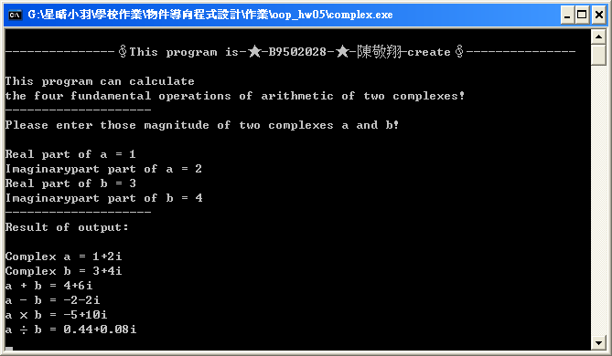

（二）Assume complex A is 4+3i, and complex B is 2+i…
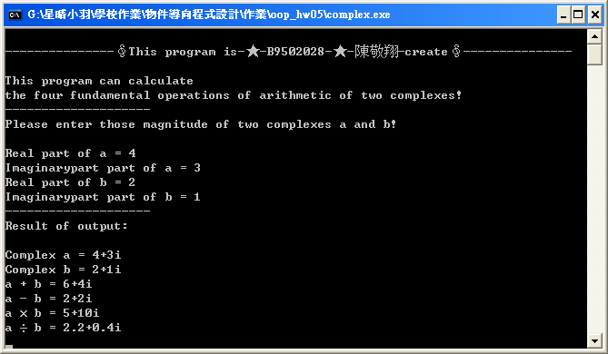
（三）Assume complex A is 999999999+999999999i, and complex B is 999999999+999999999i…
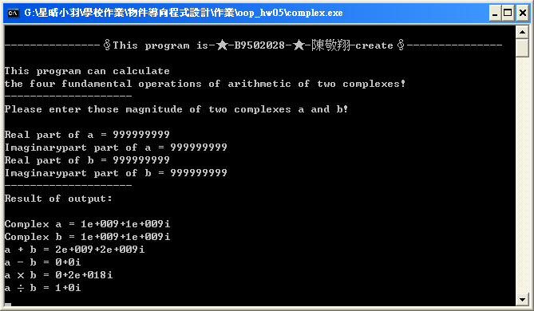

Because they are double type, they are not so easy to overflow.

（四）Assume complex A is 3+3i, and complex B is 0+0i…
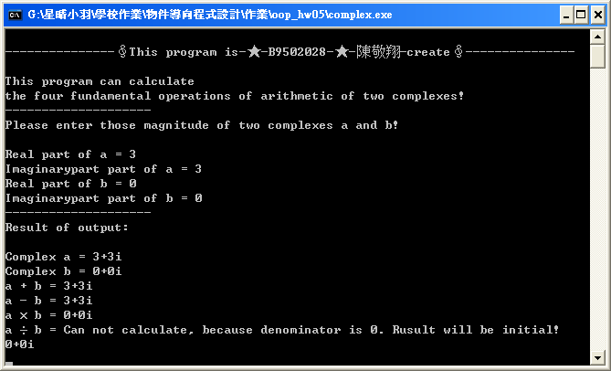

When division operation, denominator is 0.
So print initial complex data.
Problem Two
一、Date class：

This date class member include day, month and year part.
And class function include three overloading set, get, print.
Overloading type include set DDD YYYY, set MM/DD/YYYY and set such as May 16, 2007.

class date
{
private:
int day,month,year;
public:
date();
void set_date(int,int);
void set_date(short,int,int);
void set_date(char[],int,int);
void print_date();
void get_date(int&,int&,int&);
};

二、Date class function：

（一）Initial class function：
date::date()
{
day=month=year=1;
}

（二）Set DDD YYYY type function：
void date::set_date(int d,int y)
{
if(((d>365)&&(y%4!=0))||((d>366)&&(y%4==0))||(d<1)||(y<1))
{
cout<<"Date is invalid! Initial this data!"<<endl;
return;
}
int m=1;
while((d-monthday(m,y))>0)
{
d=d-monthday(m,y);
m++;
}
day=d;
month=m;
year=y;
}

（三）Set MM/DD/YYYY type function：
void date::set_date(short m,int d,int y)
{
if((d>monthday(m,y))||(d<1)||(m<1)||(m>12)||(y<1))
{
cout<<"Date is invalid! Initial this data!"<<endl;
return;
}
day=d;
month=m;
year=y;
}

（四）Set such as May 16, 2007 type function：
void date::set_date(char mon_in[],int d,int y)
{
if((d<1)||(y<1))
{
cout<<"Date is invalid! Initial this data!"<<endl;
return;
}
int i=0,m=0;
while(mon_in[i]!='\0')
{
if((mon_in[i]>='A')&&(mon_in[i]<='Z'))
{
mon_in[i]=mon_in[i]+32;
}
i++;
}
for(i=0;i<12;i++)
{
if(strcmp(mon_in,mon_con[i])==0)
{
m=i+1;
}
}
if((m==0)||(d>monthday(m,y)))
{
cout<<"Date is invalid! Initial this data!"<<endl;
return;
}
day=d;
month=m;
year=y;
}

（五）Print date function：
void date::print_date()
{
int d=day,i;
for(i=1;i<month;i++)
{
d=d+monthday(i,year);
}
cout << setfill('0') << setw(3) << d << " " << setw(4) << year << endl
<< setw(2) << month << '/' << setw(2) << day << '/' << setw(2) << year << endl
<< mon[month-1] << " " << setw(2) << day << ", " << setw(4) << year << endl;
}

（六）Set date function：
void date::get_date(int& d,int& m,int& y)
{
d=day;
m=month;
y=year;
}

（七）Calculate days of that month function （not date class function）：

Because bissextile, we have consider this problem.
That can calculate correct day in that month.
If bissextile, amounts to 29 days in February.
If common, amounts to 28 days in February.
Amounts to 31 days in January, March, May, July, August, October and December.
Amounts to 30 days in April, June, September, November.

int monthday(int month,int year)
{
if(month<=7)
{
if((month==2)&&((year%4)==0))
{
return 29;
}
else if((month==2)&&((year%4)!= 0))
{
return 28;
}
else if((month%2==1)&&(month!=2))
{
return 31;
}
else
{
return 30;
}
}
else
{
if(month%2==0)
{
return 31;
}
else
{
return 30;
}
}
}

三、Total program and notes：
#include<iostream>
#include<iomanip>
//Using directive.
using namespace std;
char mon[12][10]={{"January"},{"February"},{"March"},{"April"},{"May"},{"June"},{"July"},{"August"},{"September"},{"October"},{"November"},{"December"}};
char mon_con[12][10]={{"jan"},{"feb"},{"mar"},{"apr"},{"may"},{"jun"},{"jul"},{"aug"},{"sep"},{"oct"},{"nov"},{"dec"}};
//Calculate days of that month.
int monthday(int month,int year)
{
//Because amounts to 31 days in August of July, it is a piece of intersection there.
if(month<=7)
{
//If bissextile, amounts to 29 days in February.
if((month==2)&&((year%4)==0))
{
return 29;
}
//If common, amounts to 28 days in February.
else if((month==2)&&((year%4)!= 0))
{
return 28;
}
//Amounts to 31 days in January, March, May and July.
else if((month%2==1)&&(month!=2))
{
return 31;
}
//Amounts to 30 days in April and June.
else
{
return 30;
}
}
else
{
//Amounts to 31 days in August, October and December.
if(month%2==0)
{
return 31;
}
//Amounts to 30 days in September and November.
else
{
return 30;
}
}
}
//Date class, that members include day, month and year that are private.
class date
{
private:
//Date three members.
int day,month,year;
public:
//Initial class function, magnitude is 1.
date();
//Overloading 1, this class function can set DDD YYYY.
void set_date(int,int);
//Overloading 2, this class function can set MM/DD/YYYY.
void set_date(short,int,int);
//Overloading 3, this class function can set such as May 16, 2007.
void set_date(char[],int,int);
//Print out the three type date data.
void print_date();
//Get the date data by reference indirectly.
void get_date(int&,int&,int&);
};
//Initial class function.
date::date()
{
day=month=year=1; //magnitude is 1.
}
//Overloading 1, this class function can set DDD YYYY.
void date::set_date(int d,int y)
{
//There are 365 days in common year, there are 366 days in bissextile, and day and month must more than 1.
if(((d>365)&&(y%4!=0))||((d>366)&&(y%4==0))||(d<1)||(y<1))
{
cout<<"Date is invalid! Initial this data!"<<endl;
return; //Date is invalid, so function end.
}
int m=1; //Before function beginning, it is one to set up the month to count.
while((d-monthday(m,y))>0) //Calculate which month and how many days?
{
d=d-monthday(m,y); //Call calculate days of that month function reduce for day.
m++; //Enough reduce for day, next month.
}
day=d; //Set finish!
month=m;
year=y;
}
//Overloading 2, this class function can set MM/DD/YYYY.
void date::set_date(short m,int d,int y)
{
//Determine whether day invalid, and day and month must more than 1.
if((d>monthday(m,y))||(d<1)||(m<1)||(m>12)||(y<1))
{
cout<<"Date is invalid! Initial this data!"<<endl;
return; //Date is invalid, so function end.
}
day=d; //Set finish!
month=m;
year=y;
}
//Overloading 3, this class function can set such as May 16, 2007.
void date::set_date(char mon_in[],int d,int y)
{
if((d<1)||(y<1)) //Day and month must more than 1.
{
cout<<"Date is invalid! Initial this data!"<<endl;
return;//Date is invalid, so function end.
}
int i=0,m=0; //Creat two variable, i is loop control, m is month register.
while(mon_in[i]!='\0') //English is capitalized and changed into small letter, small letter is not changed.
{
if((mon_in[i]>='A')&&(mon_in[i]<='Z'))
{
mon_in[i]=mon_in[i]+32;
}
i++;
}
for(i=0;i<12;i++)
{
if(strcmp(mon_in,mon_con[i])==0) //Compare you enter string. If equal, return 0. Represent this month.
{
m=i+1; //Record this month.
}
}
//Month can not get, represent you enter invalid value. And Determine whether day is invalid.
if((m==0)||(d>monthday(m,y)))
{
cout<<"Date is invalid! Initial this data!"<<endl;
return; //Date is invalid, so function end.
}
day=d; //Set finish!
month=m;
year=y;
}
//Print out the three type date data.
void date::print_date()
{
int d=day,i;
for(i=1;i<month;i++) //Use known day data calculate which days in one year. For print third type.
{
d=d+monthday(i,year);
} //Print three type. And function "setfill('0')" determine use '0' fill space. Function "setw(2)" use two spaces.
cout << setfill('0') << setw(3) << d << " " << setw(4) << year << endl
<< setw(2) << month << '/' << setw(2) << day << '/' << setw(2) << year << endl
<< mon[month-1] << " " << setw(2) << day << ", " << setw(4) << year << endl;
}
void date::get_date(int& d,int& m,int& y) //Get the date data by reference indirectly.
{
d=day;
m=month;
y=year;
}
//Main program.
int main(void)
{
cout<<"\n---------------∮This program is-★-B9502028-★-陳敬翔-create∮---------------\n\nThis program can output the date in multiple formats such as:\n(1)DDD YYYY\n(2)MM/DD/YYYY\n(3)May 16, 2007\n\nand can compare two dates you input!\nFirst, please choose the input way reference following,\nthen input two dates, use the space key to divide data of date!\n--------------------\nInput way:\n(1)DDD YYYY\n(2)MM/DD/YYYY\n(3)May 16, 2007\nChoose one:";
date date_one,date_two; //Declare two date class.
short cho=0;
int m,d,y;
char m_con[4];
while((cho<1)||(cho>3)) //Choose enter type, if you enter invalid data, must be retry.
{
cin>>cho;
if((cho<1)||(cho>3))
{
cout<<"Date is invalid! Try again!\nchoose one:";
}
}
cout<<"--------------------\nMode"<<cho<<"!\nPlease enter first date data:";
if(cho==1) //Overload 1, and set two date data.
{
cin>>d>>y;
date_one.set_date(d,y);
cout<<"Please enter second date data:";
cin>>d>>y;
date_two.set_date(d,y);
}
else if(cho==2) //Overload 2, and set two date data.
{
cin>>m>>d>>y;
date_one.set_date(m,d,y);
cout<<"Please enter second date data:";
cin>>m>>d>>y;
date_two.set_date(m,d,y);
}
else if(cho==3) //Overload 3, and set two date data.
{
cin>>m_con>>d>>y;
date_one.set_date(m_con,d,y);
cout<<"Please enter second date data:";
cin>>m_con>>d>>y;
date_two.set_date(m_con,d,y);
}
cout<<"--------------------\nResult of utput:\n\nDate one:\n";
date_one.print_date(); //Print out date one.
cout<<"\nDate two:\n";
date_two.print_date(); //Print out date two.
int d1,m1,y1,d2,m2,y2; //Star to compare these two date size. First create six variable to save these two date data.
date_one.get_date(d1,m1,y1); //Save first date.
date_two.get_date(d2,m2,y2); //Save second date.
if(y1<y2) //Comepare year, month and year.
{
cout<<"\nFirst date is prior!";
}
else if(y1==y2)
{
if(m1<m2)
{
cout<<"\nFirst date is prior!";
}
else if(m1==m2)
{
if(d1<d2)
{
cout<<"\nFirst date is prior!";
}
else if(d1==d2)
{
cout<<"\nFirst and second date are same!";
}
else if(d1>d2)
{
cout<<"\nSecond date is prior!";
}
}
else if(m1>m2)
{
cout<<"\nSecond date is prior!";
}
}
else if(y1>y2)
{
cout<<"\nSecond date is prior!";
}
getchar();
getchar();
return 0;
}
四、Running result：

（一）Overloading one, assume date one is 123 2007, and date two is 321 1987…
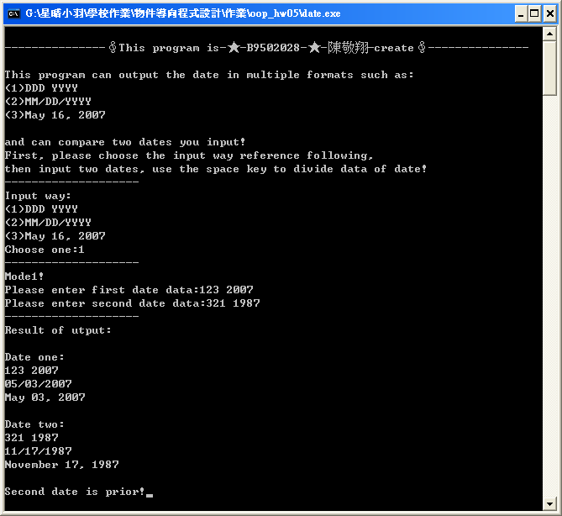
（二）Overloading two, assume date one is 12/30/2000, and date two is 12/30/2000…
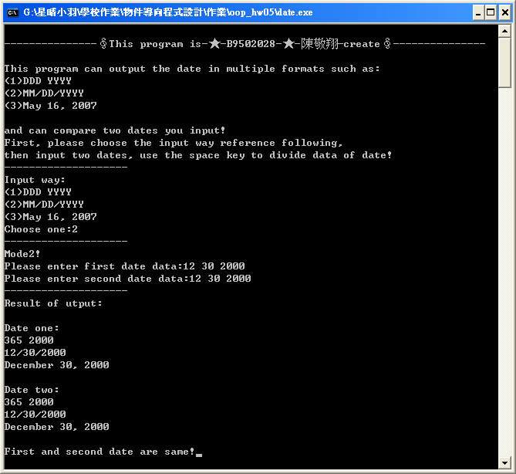
（三）Overloading three, assume date one is May 16, 2007, and date two is Jun 20, 2007…
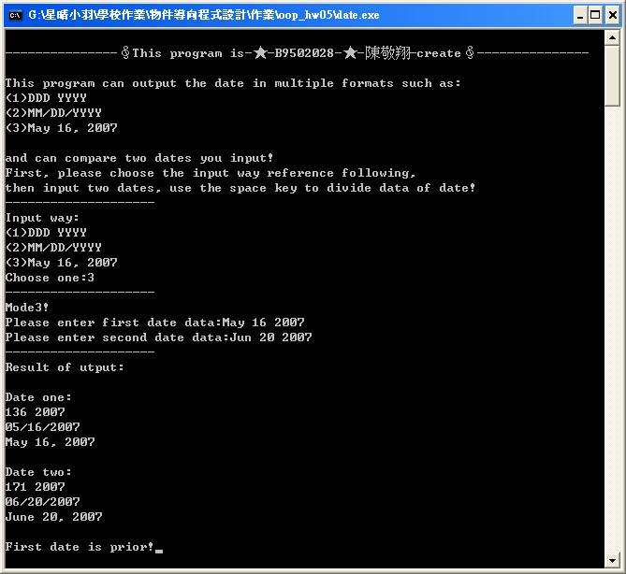
（四）Overloading three, assume date one is Feb 16, 2007, and date two is Sep 50, 2007…

Date two is invalid, so date two will be initial.
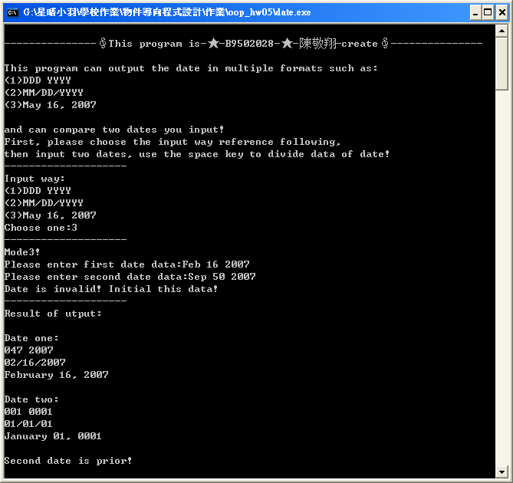

（五）Overloading two, assume date one is 13 20, 2000, and date two is 10 12, 2003…

Date one is invalid, so date one will be initial.
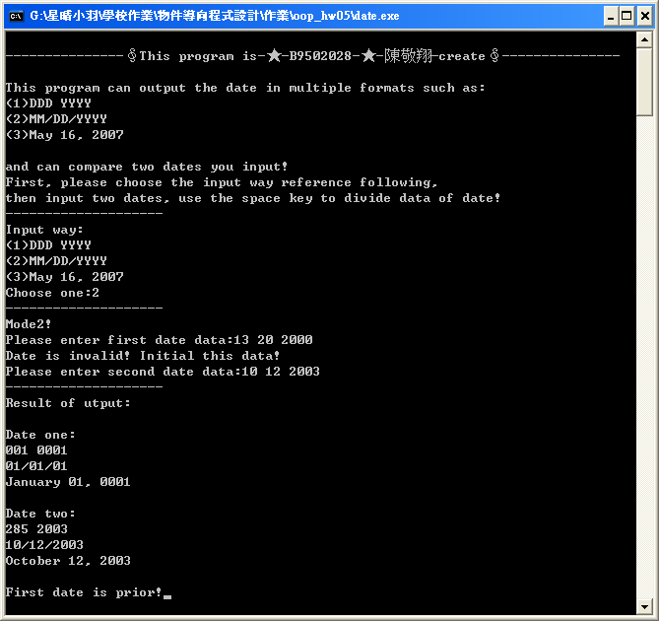

（六）If you enter invalid overloading type…
